**DSNP Disaster Response Pipeline - Output**

1. Run the following commands in the project's root directory to set up your database and model.

* 1. run ETL pipeline that cleans data and stores in database - COMPLETED

*python data/process_data.py data/disaster_messages.csv data/disaster_categories.csv data/DisasterResponse.db*

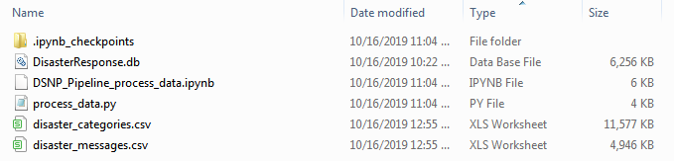

* 1. run ML pipeline that trains classifier and saves - COMPLETED

*python models/train_classifier.py data/DisasterResponse.db models/classifier.pkl*

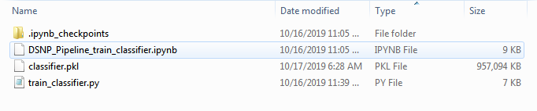

1. Run the following command in the app's directory to run your web app.

*python run.py*

1. Go to ***http://localhost:3001*** ( using local pc, DON’T USE http://0.0.0.0:3001/)

**Final Web output and Testing**

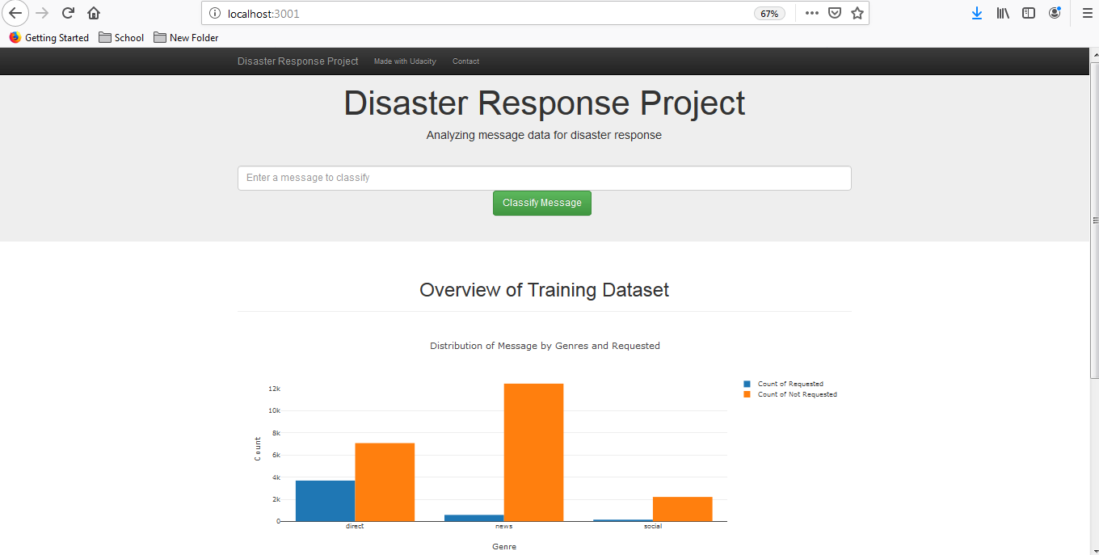

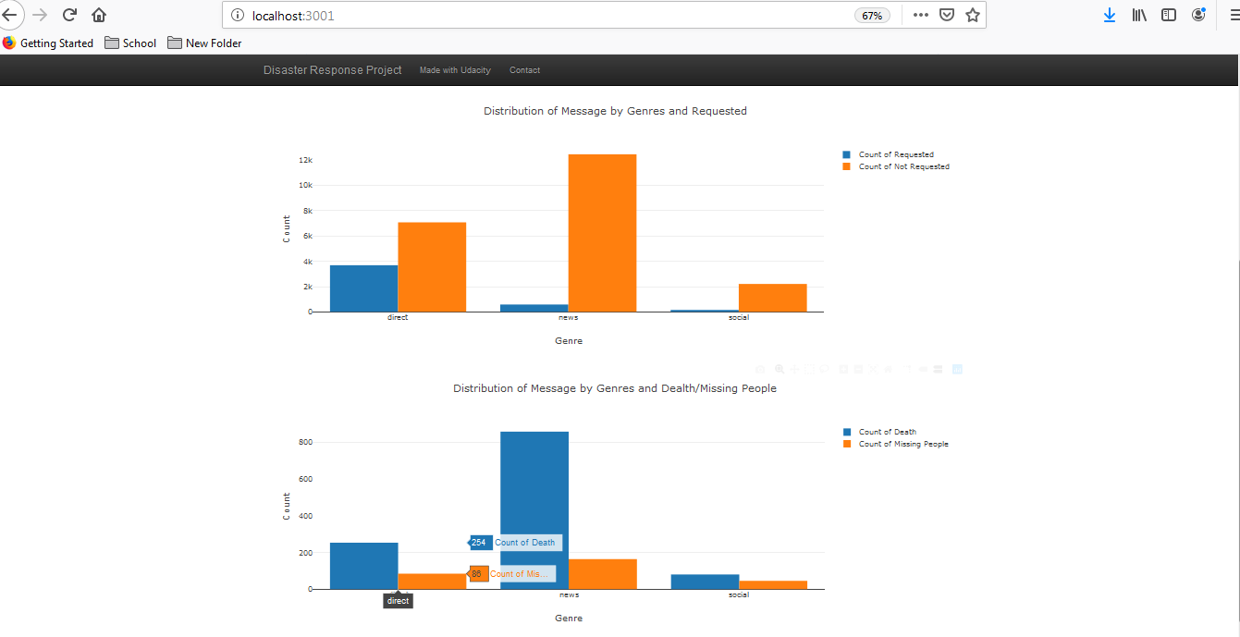

**Testing message:**

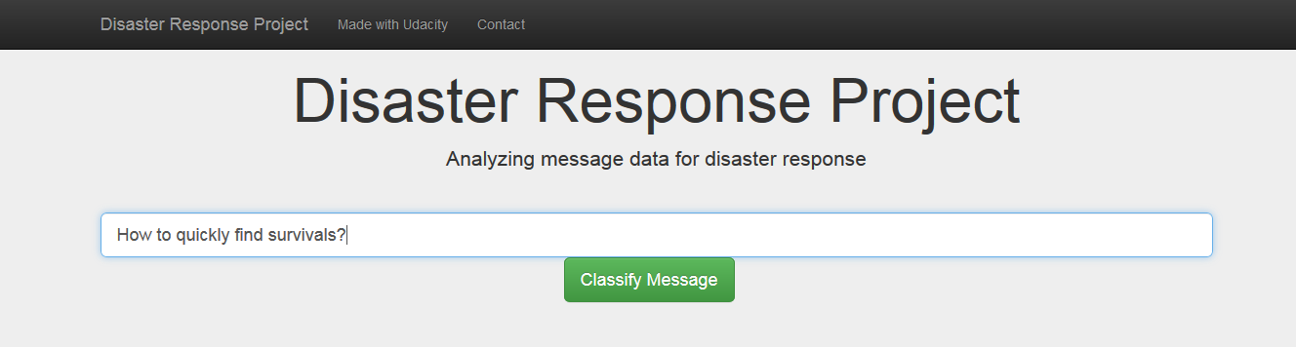

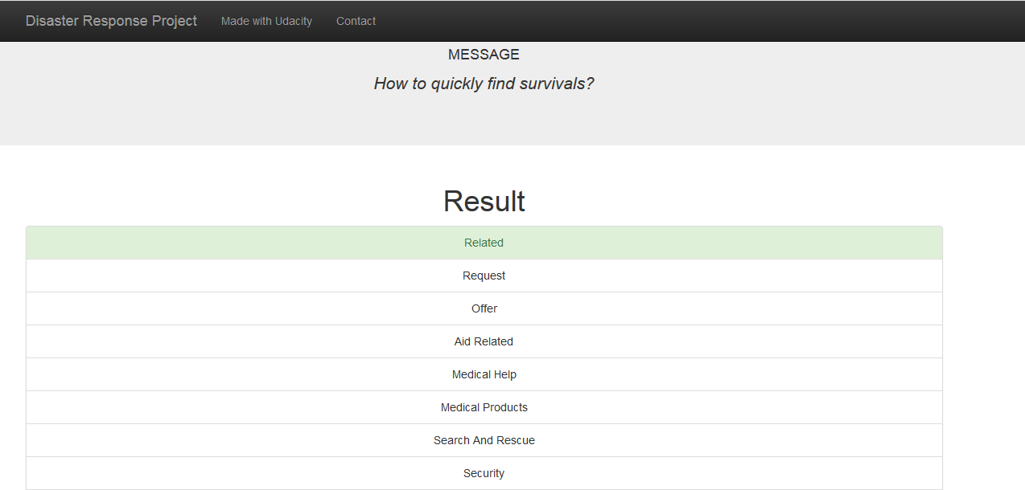

Another test:

